Multiple Choice Questions

1) | When comparing the energy in stored fat (triacylglycerols) versus the energy in stored glycogen, what must be taken into account to determine the actual energy available per gram of metabolite?

A) | fats are more highly oxidized than glycogen
B) | fats are anhydrous while glycogen binds large amounts of water
C) | fats are neutral while glycogen is highly charged
D) | fats are attached to protein while glycogen is not
E) | all of the above

Answer: B

Difficulty: 2 Topic: Utilization and Transport of Fat and Cholesterol

2) | Which of the following lipoproteins distributes dietary lipids?

A) | chylomicron
B) | very low density lipoprotein
C) | intermediate density lipoprotein
D) | low density lipoprotein
E) | high density lipoprotein

Answer: A

Difficulty: 1 Topic: Utilization and Transport of Fat and Cholesterol

3) | A(n) ___________ is converted to a(n) _____________ by loss of triacylglycerols.

A) | chylomicron; very low density lipoprotein
B) | low density lipoprotein; high density lipoprotein
C) | very low density lipoprotein; intermediate density lipoprotein
D) | low density lipoprotein; very low density lipoprotein
E) | intermediate density lipoprotein; very low density lipoprotein

Answer: C

Difficulty: 2 Topic: Utilization and Transport of Fat and Cholesterol

4) | Which of the following roles does the liver play in lipoprotein metabolism?

A) | production of chylomicrons
B) | uptake of VLDL
C) | production of LDL
D) | uptake of HDL
E) | none of the above

Answer: D

Difficulty: 2 Topic: Utilization and Transport of Fat and Cholesterol

5) | Which of the following events occurs first in the process of transporting an LDL into a cell?

A) | formation of a coated pit with the aid of clathrin
B) | receptor-mediated endocytosis
C) | fusion of the clathrin-lined vesicles to produce an endosome
D) | fusion of the cell membrane around the LDL particle
E) | interaction of apoprotein B-100 with the LDL receptor

Answer: E

Difficulty: 2 Topic: Utilization and Transport of Fat and Cholesterol

6) | Which of the following leads to the formation of atherosclerotic plaques?

A) | non-specific interactions between LDL particles
B) | oxidation of LDL particles resulting in cross linking with proteins
C) | uptake of oxidized LDL particles by macrophages
D) | excess uptake of LDL particles converting endothelial cells to foam cells
E) | none of the above

Answer: C

Difficulty: 2 Topic: Utilization and Transport of Fat and Cholesterol

7) | The enzymes that are responsible for the hydrolysis of triacylglycerols in adipocytes are _________ esterases.

A) | serine
B) | cysteine
C) | tyrosine
D) | histidine
E) | aspartate

Answer: A

Difficulty: 1 Topic: Utilization and Transport of Fat and Cholesterol

8) | The primary activation of triacylglycerol mobilization in adipocytes is through __________ of the enzyme ____________.

A) | phosphorylation; perilipin
B) | phosphorylation; hormone sensitive lipase
C) | dephosphorylation; hormone sensitive lipase
D) | phosphorylation; adipose triglyceride lipase
E) | dephosphorylation; adipose triglyceride lipase

Answer: B

Difficulty: 2 Topic: Utilization and Transport of Fat and Cholesterol

9) | In the mitochondrion, as a ______________ moves from the intermembrane space to the matrix, ___________ is transported in the opposite direction.

A) | fatty acyl-CoA; CoA
B) | fatty acyl-carnitine; carnitine
C) | fatty acyl-CoA; carnitine
D) | fatty acyl-carnitine; CoA
E) | fatty acid; acetyl-CoA

Answer: B

Difficulty: 2 Topic: Fatty Acid oxidation

10) | Which of the following is the major regulation point for transport of fatty acids into the mitochondria?

A) | long chain fatty acid specific acyl-CoA synthetase
B) | medium chain fatty acid specific acyl-CoA synthetase
C) | short chain fatty acid specific acyl-CoA synthetase
D) | carnitine acyltransferase I
E) | carnitine acyltransferase II

Answer: D

Difficulty: 2 Topic: Fatty Acid oxidation

11) | Which of the following represents the correct sequence of events in a cycle of β-oxidation beginning with a saturated fatty acyl-CoA?

A) | hydration, FAD-coupled oxidation, NAD⁺-coupled oxidation, thiolytic cleavage
B) | FAD-coupled oxidation, hydration, NAD⁺-coupled oxidation, thiolytic cleavage
C) | FAD-coupled oxidation, NAD⁺-coupled oxidation, hydration, thiolytic cleavage
D) | NAD⁺-coupled oxidation, FAD-coupled oxidation, hydration, thiolytic cleavage
E) | NAD⁺-coupled oxidation, hydration, FAD-coupled oxidation, thiolytic cleavage

Answer: B

Difficulty: 2 Topic: Fatty Acid oxidation

12) | The first three reactions of β-oxidation are analogous to which of the following reaction sequences of the citric acid cycle?

A) | aconitase, isocitrate dehydrogenase, α-ketoglutarate dehydrogenase
B) | isocitrate dehydrogenase, α-ketoglutarate dehydrogenase, succinyl-CoA synthetase
C) | α-ketoglutarate dehydrogenase, succinyl-CoA synthetase, succinate dehydrogenase
D) | succinate dehydrogenase, fumarase, malate dehydrogenase
E) | fumarase, malate dehydrogenase, citrate synthase

Answer: D

Difficulty: 3 Topic: Fatty Acid oxidation

13) | What enzyme activities are found in the mitochondrial trifunctional protein that metabolizes long chain (LC) fatty acids?

A) | LC-enoyl-CoA hydratase, LC-hydroxyacyl-CoA dehydrogenase, LC-thiolase
B) | LC-acyl-CoA synthetase, LC-acyl-CoA dehydrogenase, LC-enoyl-CoA hydratase
C) | LC-carnitine acyltransferase II, LC-acyl-CoA dehydrogenase, LC-enoyl-CoA hydratase
D) | LC-acyl-CoA dehydrogenase, LC-enoyl-CoA hydratase, LC-hydroxyacyl-CoA dehydrogenase
E) | LC-acyl-CoA dehydrogenase, LC-hydroxyacyl-CoA dehydrogenase, LC-thiolase

Answer: A

Difficulty: 3 Topic: Fatty Acid oxidation

14) | Individuals with diets high in coconut oil consume large amounts of lauric (12:0). What are the β-oxidation products of lauric acid?

A) | 6 acetyl-CoA, 6 NADH, 6 FADH₂, 1 ATP used for activation
B) | 6 acetyl-CoA, 5 NADH, 5 FADH₂, 1 ATP used for activation
C) | 6 acetyl-CoA, 6 NADH, 6 FADH₂, 2 ATP used for activation
D) | 6 acetyl-CoA, 5 NADH, 5 FADH₂, 2 ATP used for activation
E) | none of the above

Answer: D

Difficulty: 2 Topic: Fatty Acid oxidation

15) | For the β-oxidation of a fatty acid with notation of 18:3cΔ6,9,12, how many NADPH would be required and how many FADH₂ would be produced?

A) | 1 NADPH, 7 FADH₂
B) | 1 NADPH, 8 FADH₂
C) | 2 NADPH, 6 FADH₂
D) | 2 NADPH, 7 FADH₂
E) | 2 NADPH, 8 FADH₂

Answer: D

Difficulty: 3 Topic: Fatty Acid oxidation

16) | Low levels of oxaloacetate with high levels of β-oxidation cause the production of what metabolites, particularly within the liver?

A) | acetate and ethanol
B) | acetoacetate and β-hydroxybutyrate
C) | 3-hydroxy-3-methyglutaryl-CoA and propionyl-CoA
D) | D-methylmalonyl-CoA and L-methylmalonyl-CoA
E) | all of the above

Answer: B

Difficulty: 2 Topic: Fatty Acid oxidation

17) | Which of the following is the most important regulatory enzyme in fatty acid synthesis?

A) | citrate lyase
B) | malic enzyme
C) | acetyl-CoA carboxylase
D) | acetyl-CoA-ACP transacylase
E) | malonyl-CoA-ACP transacylase

Answer: C

Difficulty: 1 Topic: Fatty Acid Biosynthesis

18) | For each acetyl-CoA that is incorporated into a growing fatty acid, what energy inputs are required, assuming that the growing fatty acid already contains at least 4 carbons?

A) | 1 NADPH, 1 FADH₂, 1 ATP
B) | 2 NADPH, 1 ATP
C) | 2 NADPH, 1 FADH₂, 1 ATP
D) | 1 NADPH, 1 FADH₂, 2 ATP
E) | 2 NADPH, 2 ATP

Answer: B

Difficulty: 2 Topic: Fatty Acid Biosynthesis

19) | Which of the following coenzymes is required by acetyl-CoA carboxylase?

A) | NAD⁺
B) | biotin
C) | pyridoxal phosphate
D) | tetrahydrofolate
E) | none of the above

Answer: B

Difficulty: 1 Topic: Fatty Acid Biosynthesis

20) | Which of the following enzymes of fatty acid synthesis is most analogous to thiolase when considering that fatty acid synthesis is analogous to a reversal of β-oxidation?

A) | β-ketoacyl-ACP synthase
B) | β-ketoacyl-ACP reductase
C) | 3-hydroxyacyl-ACP dehydratase
D) | enoyl-ACP reductase
E) | thioesterase

Answer: A

Difficulty: 2 Topic: Fatty Acid Biosynthesis

21) | Which of the following lists the enzymes (in order) required to transport a molecule of acetyl-CoA from the mitochondrion to the cytosol while returning the “acetyl-CoA acceptor” back to the mitochondrion?

A) | citrate synthase, citrate lyase, pyruvate carboxylase
B) | citrate synthase, citrate lyase, malate dehydrogenase, pyruvate carboxylase
C) | citrate synthase, citrate lyase, malate dehydrogenase, pyruvate carboxylase, malic enzyme
D) | citrate synthase, citrate lyase, malate dehydrogenase
E) | citrate synthase, citrate lyase, malate dehydrogenase, malic enzyme

Answer: D

Difficulty: 2 Topic: Fatty Acid Biosynthesis

22) | In mammalian cells, most fatty acid elongation occurs in _____________. Most desaturation of fatty acids in mammalian cells occurs in _____________.

A) | endoplasmic reticulum; mitochondria
B) | Golgi apparatus; mitochondria
C) | endoplasmic reticulum; Golgi apparatus
D) | Golgi apparatus; mitochondria
E) | endoplasmic reticulum; endoplasmic reticulum

Answer: E

Difficulty: 2 Topic: Fatty Acid Biosynthesis

23) | The futile cycle of triacylglycerol synthesis and triacylglycerol hydrolysis is controlled largely by AMP-activated protein kinase. Which of the following enzymes is regulated by AMP-activated protein kinase?

A) | glycerol kinase
B) | pyruvate carboxylase
C) | glycerophosphate acyltransferase
D) | glycerol-3-phosphate dehydrogenase
E) | phosphoenolpyruvate carboxykinase

Answer: C

Difficulty: 2 Topic: Biosynthesis of Triacylglycerols

Short Answer Questions

1) Fill in the missing structures and any reactants or products for one complete round of β-oxidation:

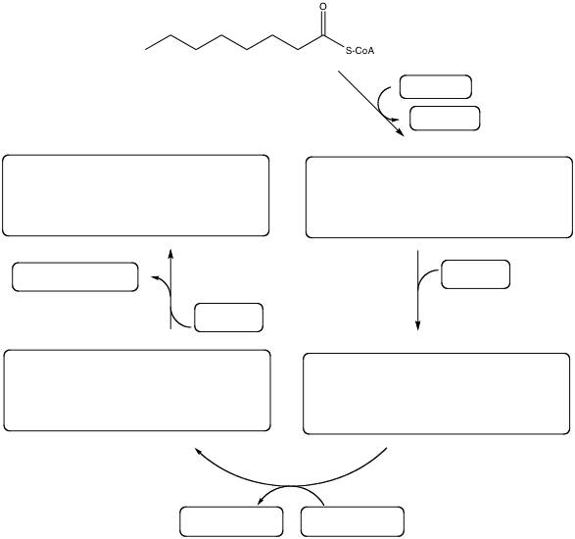

Answer:

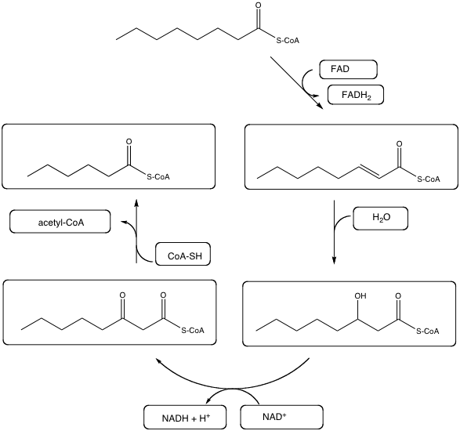

Difficulty: 2 Topic: Fatty Acid oxidation
2) If gadoleic acid (20:1cΔ9) underwent complete mitochondrial oxidation to CO₂, how many ATP could be produced assuming that all reduced electron carriers are re-oxidized by the mitochondrial electron transport chain?

Answer: Using 2.5 ATP/NADH and 1.5 ATP/FADH₂, the following table shows the reduced electron carriers and ATP equivalents from each pathway and the ultimate ATP yield.

Pathway | NADH | FADH₂, | ATP
β-oxidation (9 cycles) | 9 | 8 | -2
citric acid cycle (10 cycles) | 30 | 10 | 10
Total | 39 | 18 | 8
 | × 2.5 | × 1.5
Total ATP | 97.5 | 27 | 8

Overall total ATP: 132.5

Difficulty: 3 Topic: Fatty Acid oxidation

3) Show the result if the following fatty acid underwent one desaturation using a Δ9 desaturase followed by one round of elongation.

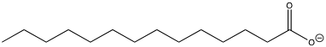

Answer:

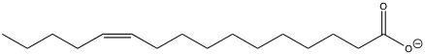

Difficulty: 2 Topic: Fatty Acid Biosynthesis

